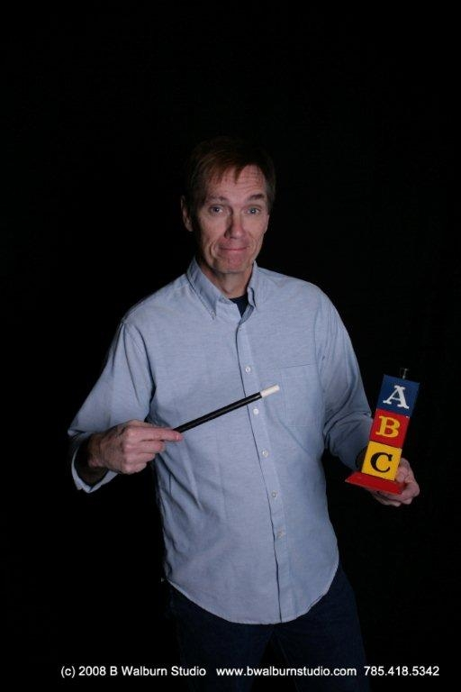
For kids entering grades 4-6
Early bird registration is $120
(Registration and $40 deposit must be postmarked by June 1)
Late registration is $140
Fees do not include transportation.

What: Kansas Wesleyan Kid’s Camp
When: June 14-17, 2010
Where: Central Christian College, McPherson, KS

Guest Speaker: Pastor Scott Dickinson
*Please bring a new or gently used stuffed animal for our missions project.

2 Timothy 1:6-7 “Fan into flame the gift of God, which is in you through the laying on of my hands. For God did not give us a spirit of timidity, but a spirit of power, of love and of self-discipline.”

Get more information and camp forms at www.kdwc.org under “kid’s ministries.”

* Awesome
Chapels

